Nathan Robertson

Technical Documentation

Table of Contents

|  |  |
| --- | --- |
| Introduction |  |
| About Classroom Robots | Page 1 |
| UML Diagrams |  |
| Main Form | Page 2 |
| Node | Page 4 |
| Tree | Page 5 |
| Student | Page 6 |
| Desk | Page 6 |
| Classroom | Page 6 |
| Debugging |  |
| Screenshot | Page 7 |

Introduction

# About Classroom Robots

Classroom Robots is the new way to keep track of your Classroom layout. Design and create new seating arrangements with ease.

# Main Form

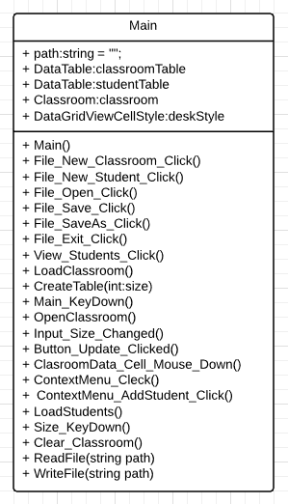

This is a UML of the Main Form of the Classroom Robots application. This is the central hub of the application.

# Node

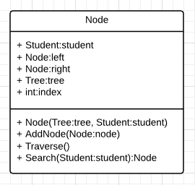

This is a UML Diagram for the Node class. It handles all the sorting and searching of the Binary tree.

# Tree

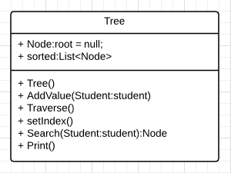

This is a UML Diagram for the Binary Tree class. It is basically just a wrapper for the Node class.

# Student

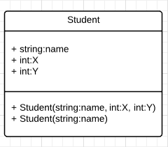

This is a UML Diagram for the Student Class. It holds all of the students information.

# Desk

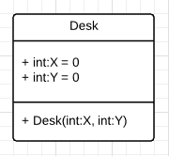

This is a UML Diagram for the Desk class. It holds the positions of the desks.

# Classroom

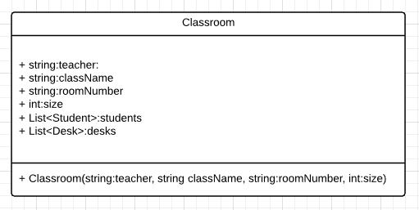

This is a UML Diagram for the Classroom class. It holds all of the information about the classroom.

# Debugging

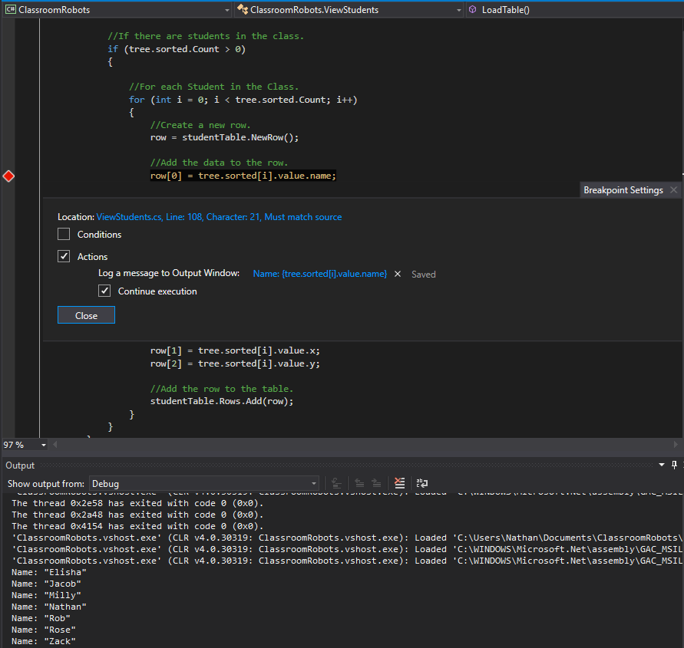

This is a screenshot of me debugging the Binary Tree, I have set a breakpoint that outputs to the console the names of the students once the binary tree has traversed and sorted the students.